Loddon, Holy Trinity, & St John's Chapel
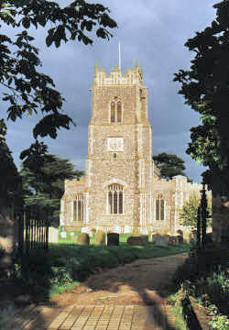
Church of England Diocese of Norwich Loddon with Hales and Heckingham
About Us
Holy Trinity Church is situated at the heart of the pleasant town of Loddon and is one of the two buildings used for worship by the Church in Loddon. The other is St. John's Methodist Church. There has been an Anglican/Methodist united Church in Loddon for more than 25 years now, and we share everything - ministers, buildings, bank account, etc. and have one Joint Church Council. We worship in Holy Trinity in the summer and in St. John's in the winter.
Our Church plays an active part in the life of the local community, and our buildings are used for all sorts of functions. Loddon is on the River Chet, with boat yards giving access to the Norfolk Broads, and holiday visitors are sure of a warm welcome at our services. Come just as you are, in your holiday clothes!
This is a single worshipping congregation (Anglican and Methodist) referred to as the Church in Loddon.
Services from the Sunday after Remembrance Sunday to mid-May are in St John's then in the summer months they are in Holy Trinity. Please check in the calendar
1st Sunday 10.45 a.m. Holy Communion (Common Worship)
2nd Sunday 10.45 a.m. Morning Worship
3rd Sunday 10.45 a.m. Holy Communion
4th Sunday 10.45 a.m. Morning Worship
Last Sunday 6.30pm for 7 Last Sunday Praise @ St John's

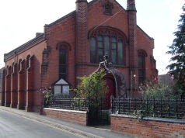
Loddon Methodist Church
St John’s Methodist Church is part of The Church in Loddon.
The Methodist and Anglican congregations formed a Local Ecumenical Project thirty years ago.
Worship is united.
Morning Worship 10.45am each week.
New Expressions worship on the first Sunday of each month at 4pm is an interactive, workshop activity time ending with All age Worship.
Festival Services and Summer Worship is held in Holy Trinity Church. We meet at St John’s Nov – March.
The Catholic congregation use the Methodist Church; Mass 11am each week.

