The Church of Christ the Cornerstone Milton Keynes
Baptist Union / Church of England / Methodist Church / Roman Catholic Church / United Reformed Church
Welcome to the Church of Christ the Cornerstone where five denominations work together, sharing the same space and a commitment to serve the people of Milton Keynes. We are a diverse community discovering and growing in the Christian faith. We experience God’s love and are challenged to live that love and share it with the wider community.

Ecumenical Council
The Ecumenical Council meets regularly to look at how we work out our vision as a church, to consider new proposals and to monitor the finance and other practical issues related to the organisation of Cornerstone. The Chair of the Council is elected from the members of Council, who are both those who are elected from the congregation at the Annual Congregational Meeting, usually held in April, and the ministers who are appointed to Cornerstone and other office holders: the treasurer and the clerk. The churchwardens and the Chair of Cornerstone Trading (MK) attend the meetings, while not being members.
Working groups (committees) have been set up from the Council to oversee different aspects of church life. The groups are: Finance & Resources, Homelessness, Pastoral, Worship.
Congregational meetings are also held where issues of importance are discussed with the whole congregation.

What happens here?
The Centre for Integrated Living, English Language House and Explicit Solutions are permanent tenants, but a whole range of community groups, churches and others use the building on a regular or occasional basis.
We are open seven days a week. On Monday–Saturday the doors are open 8.00 am–8.00 pm, although many meetings and events go on later into the evenings.
The Chapel is open 8.00 am–8.00 pm for private prayer and reflection.
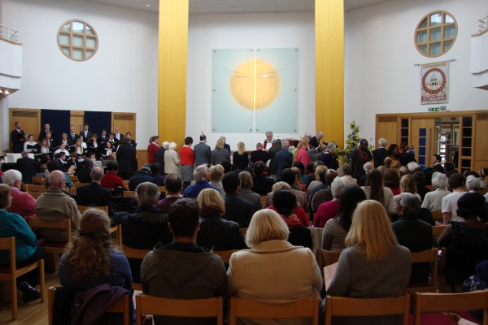
We have a shop in the foyer with cards and books and other items. You can buy things from this at any time that the Reception desk is open.
The Cornerstone Café is open 9.00 am–3.00 pm Monday–Friday for a range of teas, coffees, sandwiches, hot and cold snacks. Freshly made soup is probably the favourite.
