The Church in our Town – South Woodham Ferrars
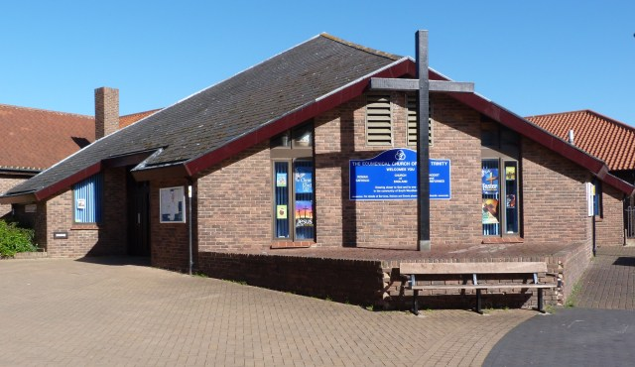
Welcome to Holy Trinity Church
Our Church was dedicated in 1982. It is Jointly owned and shared by the Catholic Church, the Church of England and the Methodist Church.
We who share this building seek, through the inspiration of God’s Spirit, to draw nearer to Him and to one another in this community

Church History
The Church of the Holy Trinity is very different; it is a new modern church. It is jointly owned and shared by not just one, but three denominations – Church of England, Catholic and Methodist.
As you see from the photograph it has a tent shaped roof made of dark grey tiles. There are no spires, no steeples and only one very modest bell. Outside the church stands a plain wooden cross 15 feet high on a raised concrete platform
To ensure the three denominations maintain the church in a manner that benefits all Parishioners and ensures a coordinated approach to the running of the church there are three groups that take on this responsibility.
They are; Joint Church Council, Fabric Committee, Worship and Outreach Committee.
Ian writes: I had a fascinating conversation with Rec Carole Ball, the priest in South Woodham Ferrars.
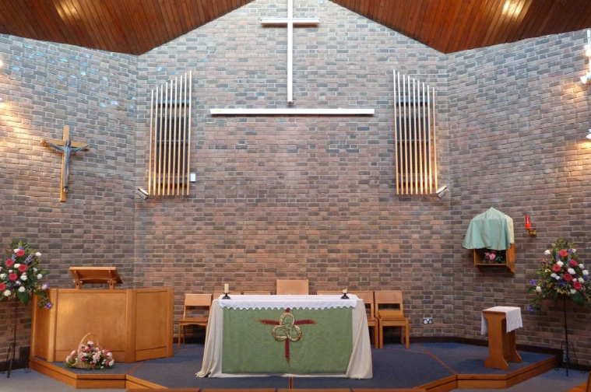
There are four constituent churches; Anglican Catholic, Methodist and URC. On Sundays they have a series of services, Catholic Mass, Anglican Holy Communion, and Free-Church Morning Worship, with coffee available between services. It is made slightly easier because the church is joined to two schools, one C of E and one Catholic. So the church can share the two school halls.
The Anglican Holy Communion is modern and family oriented, and a Book of Common Prayer morning communion is offered also some Sundays.
There is also a regular service on Thursdays at 10:00 am, which is normally led in turn by the Roman Catholic, Church of England and Methodist ministers, but from time to time may be led by any valued Lay member of the three congregations. All denominations are equally welcome at every service.
They share worship at special occasions.
The Anglican Church has strong links with the Children’s Society and the local Food Bank.
Each denomination has its own governance, its own PCC or Church Council. Each Church has its own officers and its own set of accounts.
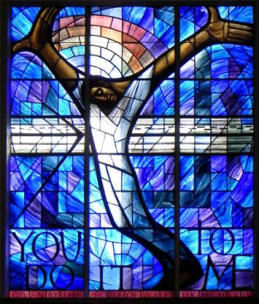
Each church has its own section of the church website where all the information and news about that church is marshalled.
Each church takes pastoral care of its own members.
The Catholic Church’s Pastoral Care Group is here for anyone in the strictest confidence.
The group provides emergency support in a wide range of areas of need.
For example: lifts to hospital, Home visits, Shopping for the housebound, Listening ears where needed

Methodist
The calling of the Methodist Church is to respond to the gospel of God’s love in Christ and to live out its discipleship in worship and mission. It does this through:
Worship, Learning & Caring, Service, Evangelism
URC
The Five Marks of Mission
To proclaim the good news of the kingdom
To teach, baptise and nurture new believer
To respond to human need by loving service
To seek to transform the unjust structures of society
To strive to safeguard the integrity of creation, to sustain and renew the life of the earth
They have a Joint Church Council with members from each church.
They also have two joint committees, one for Worship and Outreach, and one for Finance. They do as much together as they can. They each put into the fabric fund.
In the church itself there are the elements of furnishings that all the churches want. For example, the stations of the cross have been brought back from Rome by one of the members, and both Catholics through Lent, and others at Easter use the Stations for prayer and worship. The Tabernacle for reserved sacrament is shared with one side for Catholic elements and the other for Anglican. The votive candle stand is part of the furniture. It all works simply and unobtrusively.
There biggest problem is ensuring there are no clashes with room bookings!
Her over-riding sense of what made it tick was the commitment of the laity. The Priests and ministers may come and go, but it was the determination of the laity to make it work that held it firm and led it forward.
And crucial is the understanding and respect of each congregation for the other. Each accepts the legitimacy of the other.
There is nothing that cannot be done if there is a will to move forward with it.”

